Constellation Digital PCR Advantages

<http://www.formulatrix.com/demosite/pcr/index.html#tabbed-nav=tab2>

**Advantages Over Standard qPCR:**

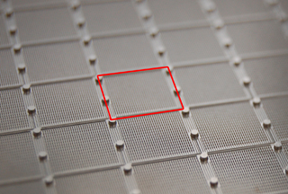  
*Fluidic layout of the microplate. Each square of microchambers is connected to one well of the 96 well microplate.*

**Robust Data**  
Because partitions with templates are cycled to completion and then counted as either positive or negative, digital PCR doesn’t require perfect amplification. Quantification using standard qPCR is sensitive to small changes in amplification efficiency, so each experiment needs to be well optimized to get accurate data. Efficiency can be affected by inhibitors in the sample, changes in annealing temperature, different master mixes, or different primers. With the Constellation dPCR system, each partition either contains the target sequence or it doesn’t, so the quantification is not affected by small differences in amplification efficiency. This allows dPCR experiments to maintain accuracy in the presence of inhibitors.

**Flexible Experimental Setup**  
Digital PCR allows for direct comparison between different targets. If many different targets are to be tested, and each primer has a slightly different efficiency due to different melting temperatures or other factors, dPCR can directly compare quantities of the different targets without time spent optimizing all of the parameters.

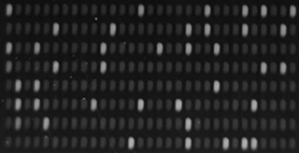  
*Example of an image with positive and negative partitions. Target copies are simply counted.*

**Direct and Absolute**  
Because the templates in the sample are simply counted, absolute quantification is easy. Standards with known quantities of the target genes don’t have to be created and pipetted to each plate. Absolute quantification allows results to be compared between different labs, different times or different experimental conditions.

**Specific**  
The Constellation dPCR microplate allows for increased specificity of detection. In cases where the target is relatively rare compared to the amount of non-target DNA, the background DNA can compete for reagents and cause non-specific amplification. Partitioning the sample into many small chambers on the dPCR microplate increases the effective concentration of rare targets in the partitions.

**High Throughput**  
The Constellation dPCR system facilitates high throughput without high capital cost. Standard qPCR requires a real-time thermal cycler for each plate for the full cycling process and scaling-up throughput requires purchasing of several real-time thermal cyclers. The Constellation dPCR microplate can be thermally cycled on non-real time thermal cyclers and then analyzed on the Constellation instrument. Thermal cyclers can easily and economically be added to increase throughput.